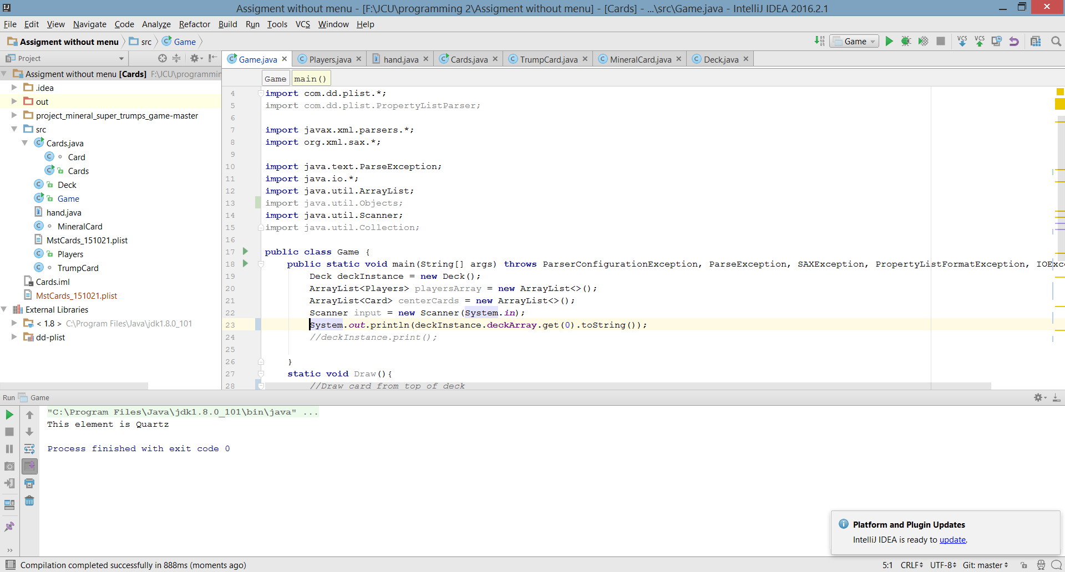

The above output is of the first element of deck is called which is defined by each Cards name from the MstCards.plist and is split into TrumpCards with their descriptions and the Mineral cards.

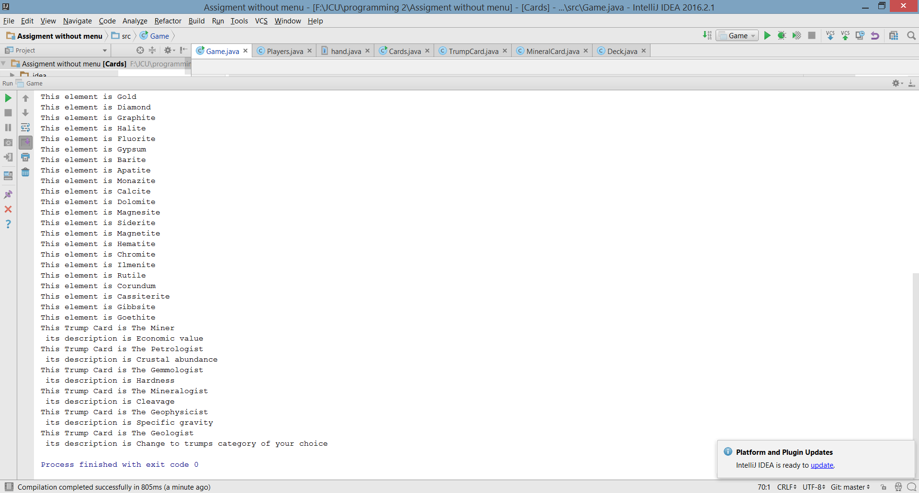

This represents the printing of the whole deck class that is unshuffled